Name: _________________________________
Below is the plan for the unit on the Paleolithic and Neolithic era. Lessons/assignments are subject to change, but this should give every student an idea on what to expect in the coming days!
Unit one: Paleolithic and Neolithic Era

Date | Lesson/Topic  Assignment | What is due?
Day one: | - Quiz on map/timeline  - Reading on Paleolithic Era  - Vocab Terms on Paleolithic Era  - Notes on Paleolithic Era  - Textbook worksheet, side one
Day two: | - Warmup Questions  - Reading on Neolithic Era  - Vocab Terms on Neolithic Era  - Notes on Neolithic Era  - Textbook worksheet, side two | Textbook worksheet, side one  Terms on Paleolithic Era
Day three: | - Warmup Questions  - Quiz on Paleolithic Era/Neolithic Era  - Civilization Notes  - Civilization Chart  - Civilization Cut/paste activity  - Finish terms | Textbook worksheet, side two  Terms on Neolithic Era
Day four: | - Unit Review  - Beginning of “Mankind”movie, episode one
Day five: | - Unit one test  - Begin new Unit | Test  Everything in packet is collected

Warmup Questions
Day one

Day two

Day three

Day four

Day five

Prehistory (Paleolithic Era and Neolithic Era) Vocabulary
Inventions of the time:
Homo Sapiens:
Caves:
Clans:
Africa:
Neolithic:
Paleolithic:
Prehistory:
2,000,000 BCE:
Hunters and gatherers:
Ice Age:
Nomadic:
Agricultural Revolution:
Permanent Dwellings:
Villages:
Domesticate:
Pottery:
Advanced tools and weapons:
Archaeologists:
Carbon 14 Dating:
Jericho and Aleppo:
Stonehenge:

Prehistory
Page 2, 3 (map and time line)
- Which happened first: The Paleolithic Age or Neolithic Age?
- In which age did the first agriculture take place?
- How many years between the beginning of the Neolithic Age and the Bronze Age?
- Where did the first humans originate? Where did they migrate?
- Find two settlements located on rivers. Why might they be located on rivers (think)?

- Why were there few sites located in Northern Europe?
Page 4
- What did early humans need to survive (think)?
- How might the tools on page 4 help humans to survive?
- What materials did early humans use from their environment to make these tools?
Page 5
- What can provide one of the richest sources of clues to a prehistoric way of life?
- What do bones and artifacts tell us about early humans?
Page7
- What is the earlier and longer part of the Stone Age called?
Page 8
- What were tools invented by Homo erectus used for?
- What did fire provide for early humans?
- How did the development of spoken language boost the chance for survival?
- How were Homo sapiens different from Homo erectus?
Page 10
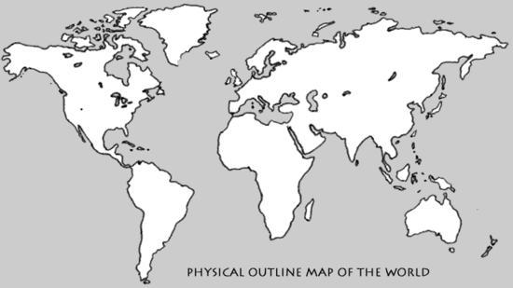
Draw lines on the map below to show migration routes of humans out of Africa

- What continent did Homo erectus migrate to first?
- Where did Homo sapiens migrate last?

Page 14
- Why were nomads always moving from place to place?
- How did hunter-gathers increase their food supply?
Page 15
- Hunter-gathers lived in bands of how many people?
- What’s another name for the Neolithic Revolution?
- Why do scientists think it happened when it did?
- How did farming offer an attractive alternative?
Page 16
- What is another word for the taming of animals?
- What advantages were there to keeping animals in man-made enclosures?
- Why were people able to settle down and build communities or villages when they learned to farm (think)?
Page 17
- Where was cotton first grown?
- Where was Catal Huyuk located? How many people lived there?
- What was this village best known for?
Complete the chart using your notes | Paleolithic Age | Neolithic Age
Food sources

Type of language
Dwellings
(Where did they live?)
Technologies
(list all)

Name____________________________________

Prehistory to Early Civilizations
Prehistory | The period of time before ____________existed. It includes the __________________ and ___________________ era
Paleolithic Era  2 million BCE to 8000 BCE |   _________Stone Age - lasted from the appearance of _______ until the development of ________________.
Where are the oldest remains of humans found? | East Africa  _________ __________ (Modern ______) emerged in __________between _____________________and 400,000 years ago.
How did geography affect the lives of early humans? | Early humans were _____________ and _____________ whose survival depended on the availability of ___________ plants and animals  They were ____________ (migrated in search of food, water, and shelter)  They ____________ from Africa to Eurasia, Australia, and the Americas
What were the characteristics of hunter-gatherer societies? | Because they followed ____________of wild animals, they lived in ______________ shelters such as __________ and tents.  Lived in __________ (extended ______________ groups)
Technology | •The way people apply _______________, __________, and inventions to meet their ______________.
What technologies were developed during the Paleolithic era? | Simple _____________ and ______________ (made from stone and wood)  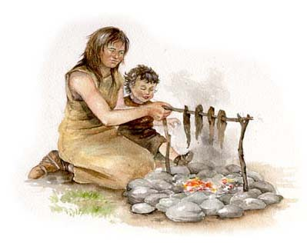  ____________ (spoken) __________________  - ____________  - ____________  ____________ ______
Neolithic Era  8000 BCE to 3500 BCE     | ___________Stone Age - period of time that ___________ when people took up ______________ (the Agricultural Revolution) and ______________ with the advent of ________________.  Humans learned how to _____________ both _________and _____________.  Domesticated (__________) animals were ___________ or herded to provide a ready supply of __________, milk, fur, etc.
How did the beginning of agriculture and the domestication of animals promote the rise of settled communities? | People could ________ in one place because they didn’t have to search for food.  They built ______________ dwellings and settled in small ________________.  They spent less time searching for food and had some 'spare time' in which to ______________ and create _________ technologies.
  What technologies were developed during the Neolithic era? | 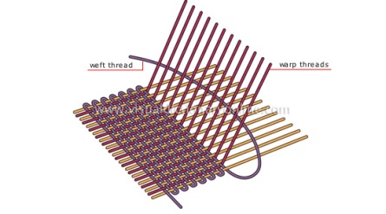  _______________  domesticated _____________  - _____________ tools and ____________  - ______________  - ______________
How do we learn about prehistoric humans? | ________________________ Study past cultures by locating and analyzing human remains, settlements, ______________, and ____________ (things __________ by people)  ________________ dating: used to find the ________ of ___________ materials.
What Neolithic sites are being studied by archaeologists today?  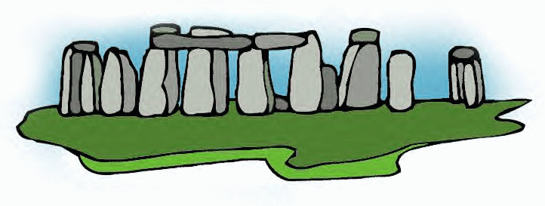 | - Aleppo and Jericho: Two of the world’s earliest ____________ located in the _____________ _________________  Catalhoyuk: An example of a large _______________ settlement currently under excavation in ___________ (present- day ________________)  Stonehenge: an example of an archaeological ________ located in ____________. It was begun during the Neolithic and completed during the _________ _______.
Civilization  What is a civilization? | A complex culture with ____________, ______________ (record keeping), a system of __________________, _________________, __________________ workers, and advanced _____________________.
What is the key feature to the emergence of civilization? | The growth of ______________
What caused cities to grow? | farming technology improved to the point that in fertile areas people were able to produce _________ _________ then they ________________.  Agricultural surplus (__________ __________) caused ___________________ to __________ and ______________ to develop.
What were the characteristics of early civilizations?  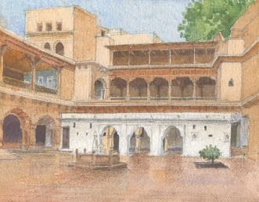  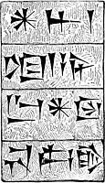   | 1. cities  2. written language/ record keeping  - _________________ language developed from ________________  - ____________________ – earliest written ___________________  3. Centralized Governments:  __________-________, _____________, and ___________  - Power was often based on ______________________ authority  4. Hereditary Rulers:  Power usually passed from __________________ to ______________.  _________________ (ruling families) of kings, emperors or pharaohs  5. Written Law Codes: such as the __________ Commandments and the _____________ of Hammurabi  6. Job Specialization: An abundant food supply allowed some people to become expert at _____________ besides farming.  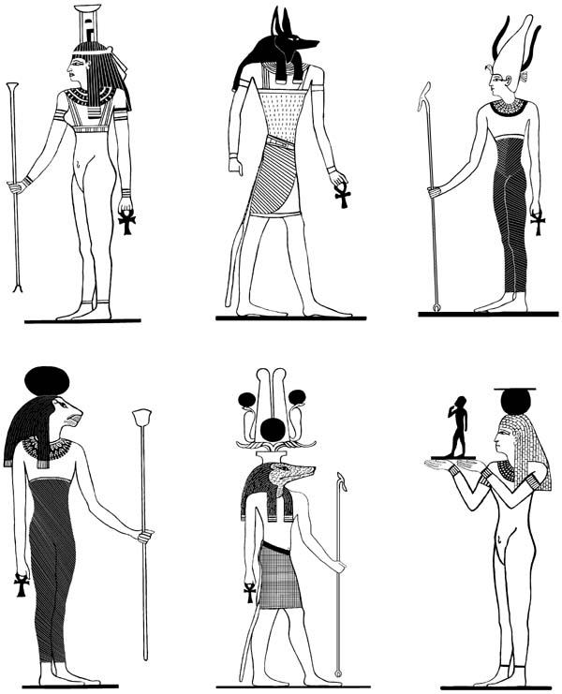  7. Rigid Class System:  Very small ___________ class: kings, nobles, priests  - Small _______________class: artisans, scribes, merchants  - Huge _______________class: peasant farmers and laborers  _________________developed in most cultures  8. Polytheism: (a belief in _________ __________) was practiced  by ____________ early civilizations  9. Metal Tools and Weapons: ___________ and _____________.

Characteristic | Description | Picture to represent this
Cities

________________ |  | 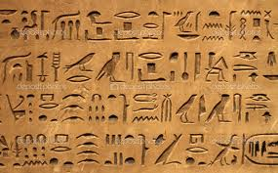
Centralized Government

________________ | - Power passed from one generation to next (father to son)  - Dynasties – ruling families in power
Written Law Codes

________________ | - People became experts at jobs outside of farming  - Farming gives people more free time for trade
Rigid Class System
Polytheism
_______________ | - Made from bronze and iron  - Hittites specialized in these  - Used for protection

Prehistory to the First Civilizations Test Review
True/False
Indicate whether the statement is true or false. If it is false, correct the statement by crossing out the incorrect word and replacing it with the correct word.

____ 1. Early written languages developed from sounds.

____ 2. Dynasties were families that ruled for generations.

____ 3. In early civilizations most people were members of the middle class.

____ 4. Most early civilizations believed that there was one God.

____ 5. Slavery was accepted in most early civilizations.

Multiple Choice
Identify the choice that best completes the statement or answers the question.

____ 6. Paleolithic humans were able to adapt to their environment by learning how to do all of the following EXCEPT
a. | make fire | c. | make tools and weapons
b. | use oral language | d. | develop written language

____ 7. Which of the following is NOTcharacteristic of governments in early civilizations?
a. | hereditary rulers | c. | city-states, kingdoms, and empires
b. | two-party system | d. | written law codes

Short Answer
8. Name five ways early humans (Paleolithic Era) were able to adapt to their environment.

9. Where did hunter-gatherers live?

10. Why couldn’t hunter gatherer’s settle in one place and build permanent dwellings?

11. What technologies enabled early humans to stop roaming and settle in one place?

12. Which era began when humans developed agriculture and domesticated animals?

13. Name three other technologies that developed during the Neolithic Era.

14. Name four Neolithic sites being studied by archaeologists today and tell where they are located.

15. What is a civilization? Circle the key feature of civilization.
16. What caused cities to grow?
17. Name four additional of early civilizations.
18. Number these events in the correct order
8,000 BCE: First grains are cultivated
476 CE: Fall of the Roman Empire
500,000 BCE: Discovery of fire
7,000 BCE: Pottery-making begins

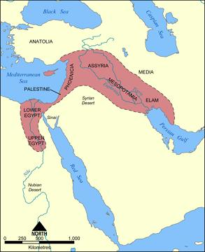
19. Two of the earliest known cities, Aleppo and Jericho, are currently being studied by archaeologists. They are located in the ____________________ _____________________.

20. Mark each of the following as characteristic of Paleolithic (P), Neolithic (N), or Civilization (C).
a. Hammurabi’s Code
b. survival depended on the availability of wild plants and animals
c. settled farming communities
d. bronze tools and weapons
e. city-states, kingdoms, and empires
f. building of Stonehenge begins
g. nomadidc lifestyle
h. pottery and weaving
i. written language
j. first use of oral language, simple tools, and fire
k. Catal Hoyuk, Aleppo, and Jericho

21. 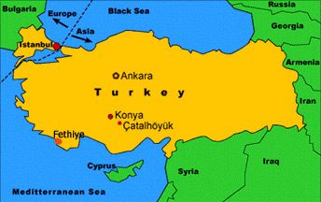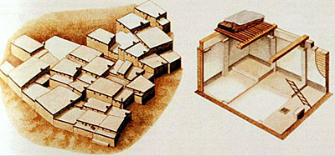
This map shows the location of the ancient settlement of Catal Hoyuk which is located today in Turkey. What is the ancient name for Turkey?

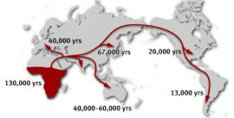
22. From which continent did man migrate from originally?
Where did humans migrate to first?
When did humans migrate to Australia?

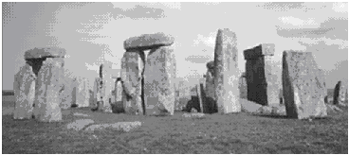
23.What is the name of this archaeological site? Where is it located? When was it built?

Essay

24. Why were early humans (Paleolithic Era) nomadic?

25. How did the development of agriculture and the domestication of animals lead to the establishment of
villages?

Prehistory Review

Matching
a. East Africa m. pictogram
b. agriculture n. herditary rulers
c. domestication o. artifacts
d. migration p. carbon-14 dating
e. Fertile Crescent q. clans
f. Old Stone Age r. Homo sapiens
g. New Stone Age s. written laws
h. archaeologists t. civilizations
i. polytheism u. irrigation
j. plow v. nomads
k. centralized governments w. food
l. written language
____ 1. Paleolithic Era
____ 2. The movement people or animals from one place to another is called
____ 3. Scientists who study past cultures are called
____ 4. Aleppo and Jericho are early Neolithic cities that developed in the
____ 5. modern humans
____ 6. farming
____ 7. taming and breeding of plants and animals for human use
____ 8. Neolithic Era
____ 9. man-made method of watering crops
___ 10. farming tool which loosens the soil
____ 11. better tools, plows, and irrigation led to a surplus of
____ 12. people who migrate (usually following migrating animals)
____ 13. prehistoric refers to the time before
____ 14. Early humans emerged in
____ 15. A scientific test used to determine the age of fossils and artifacts
____ 16. Humans of the Old Stone Age lived in family groups called
____ 17. things made by people
____ 18. Because kings (monarchs) pass power through the family they are considered to be
____ 19. metal tools and weapons (bronze and iron) are characteristic of early
____ 20. Hammurabi’s Code and the Ten Commandments are examples of
____ 21. Belief in many gods (practiced by most early civilizations)
____ 22. early written picture symbols
____ 23. city-states, kingdoms, and empires are examples of

