Penny Makes Spanakopita

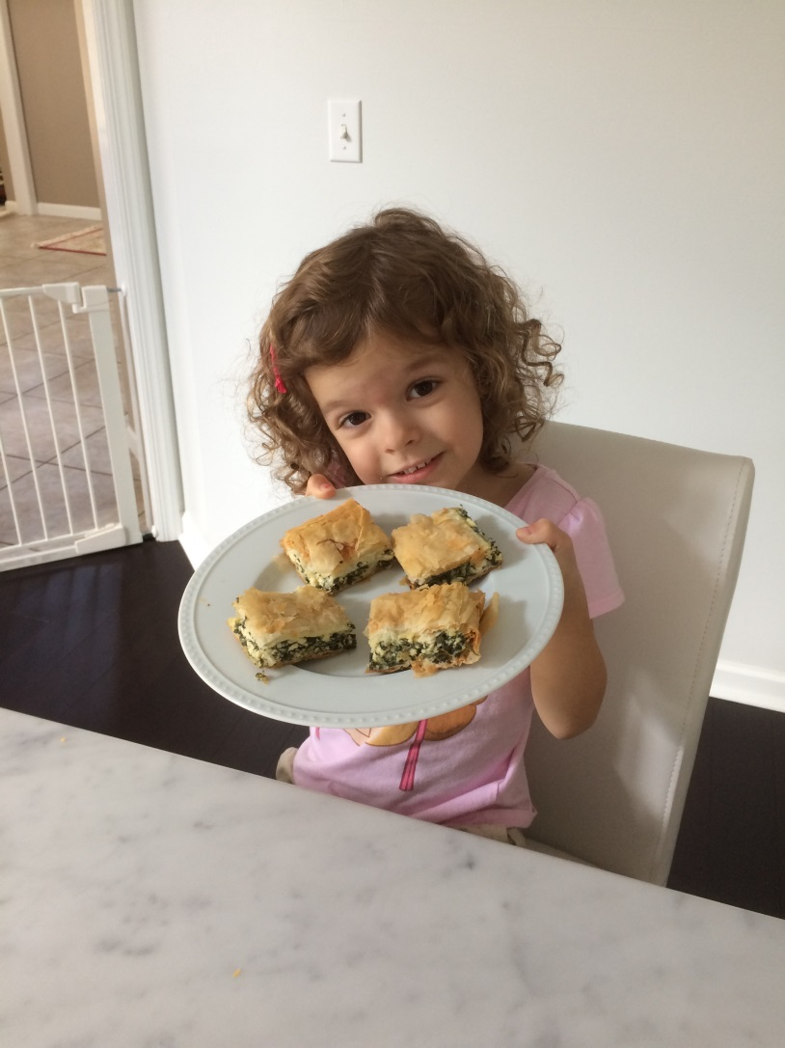

Author Penny Olsen
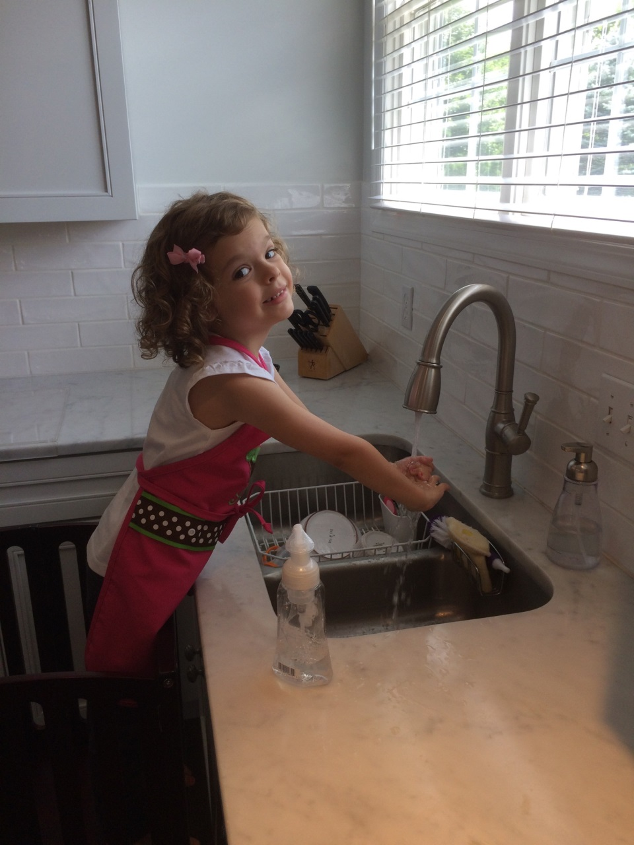

Before you do any cooking, it is important to remember to wash your hands.
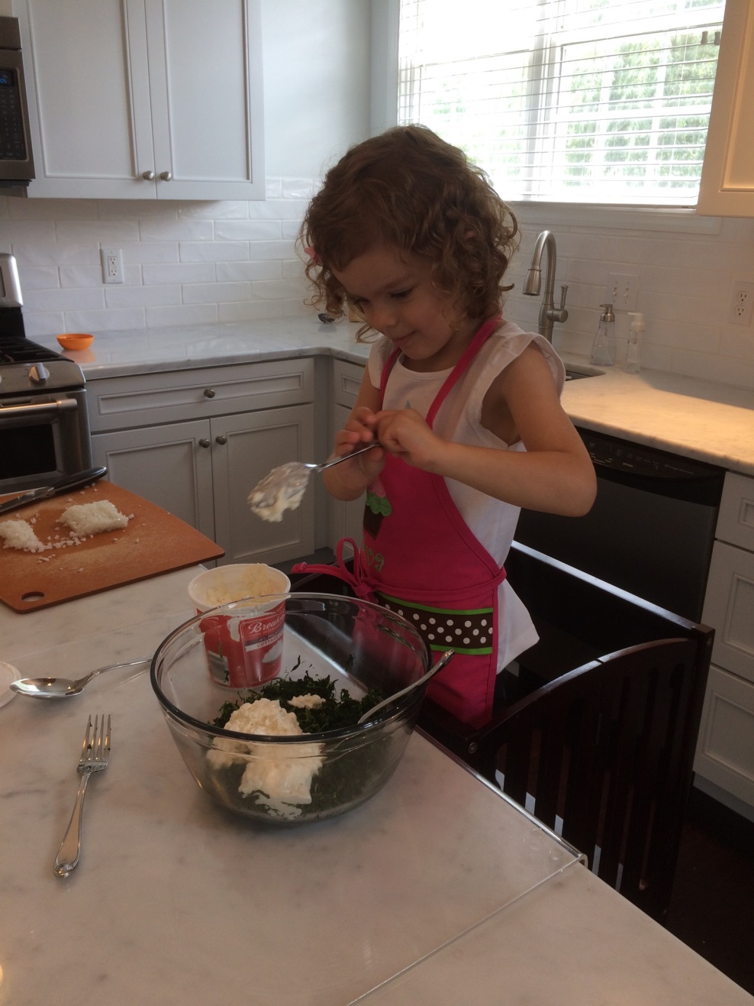

First, Ava puts the spinach in the bowl and adds cottage cheese.
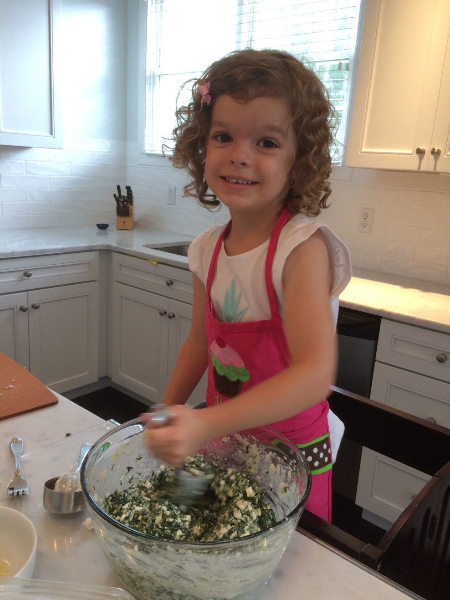

Next, Ava adds parmesan cheese, onions, eggs and dill. She mixes everything together.
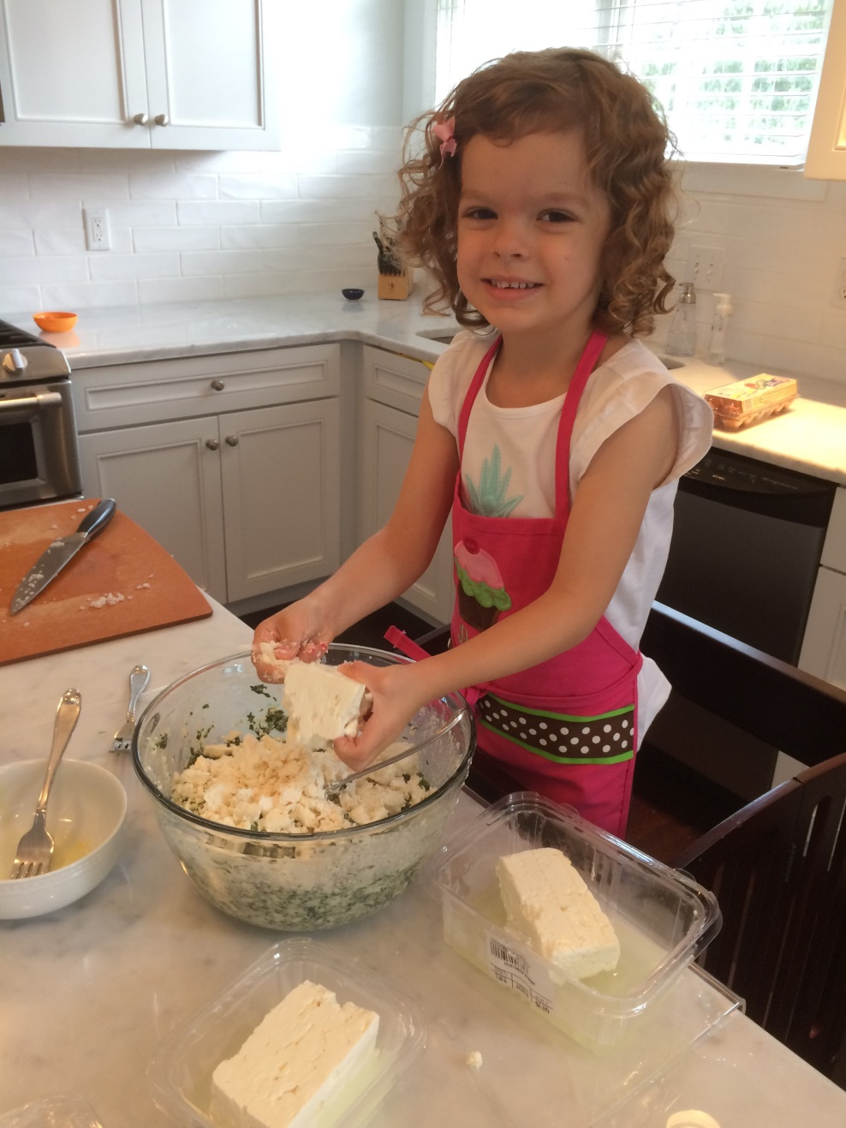

Third, Ava crumbles up feta cheese and adds it to the spinach mixture.
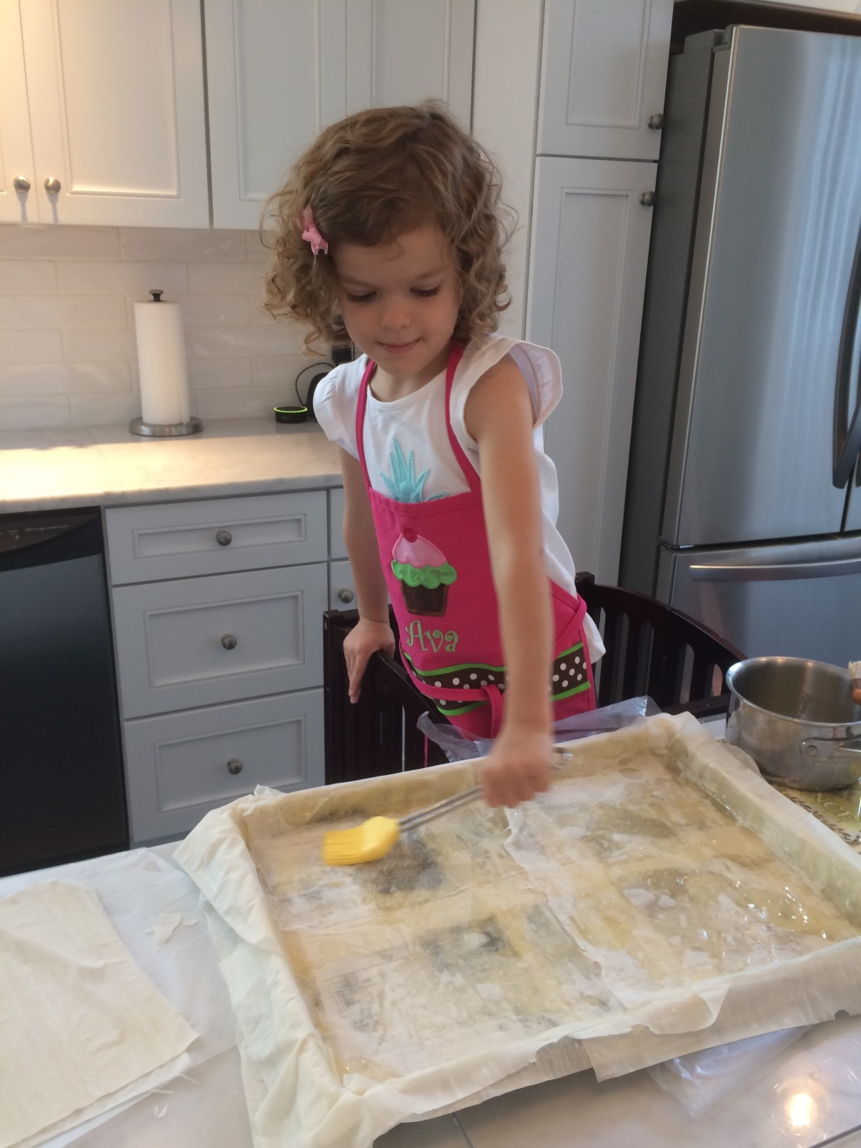

Fourth, Ava lines a baking sheet with 10 layers of filo dough and melted butter.
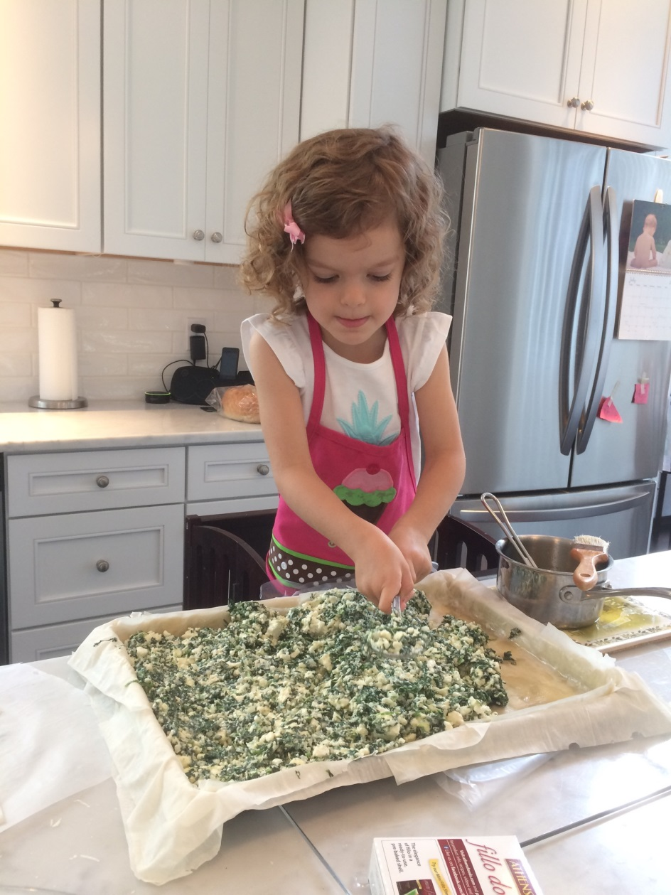

Next, Ava spreads the spinach mixture over the layers of filo dough and melted butter.
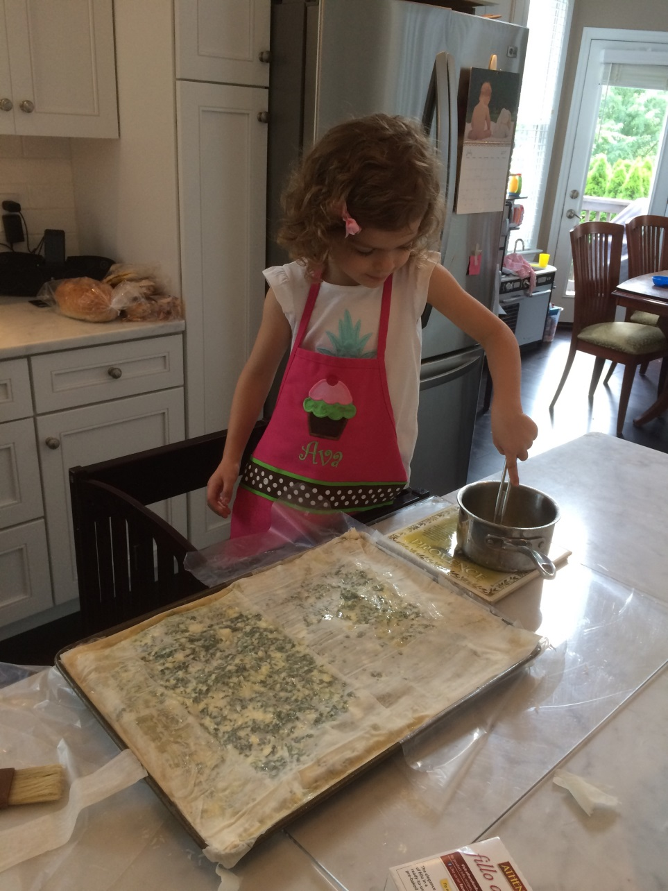

Last, Ava puts 10 more layers of filo dough and melted butter on top of the spinach mixture.
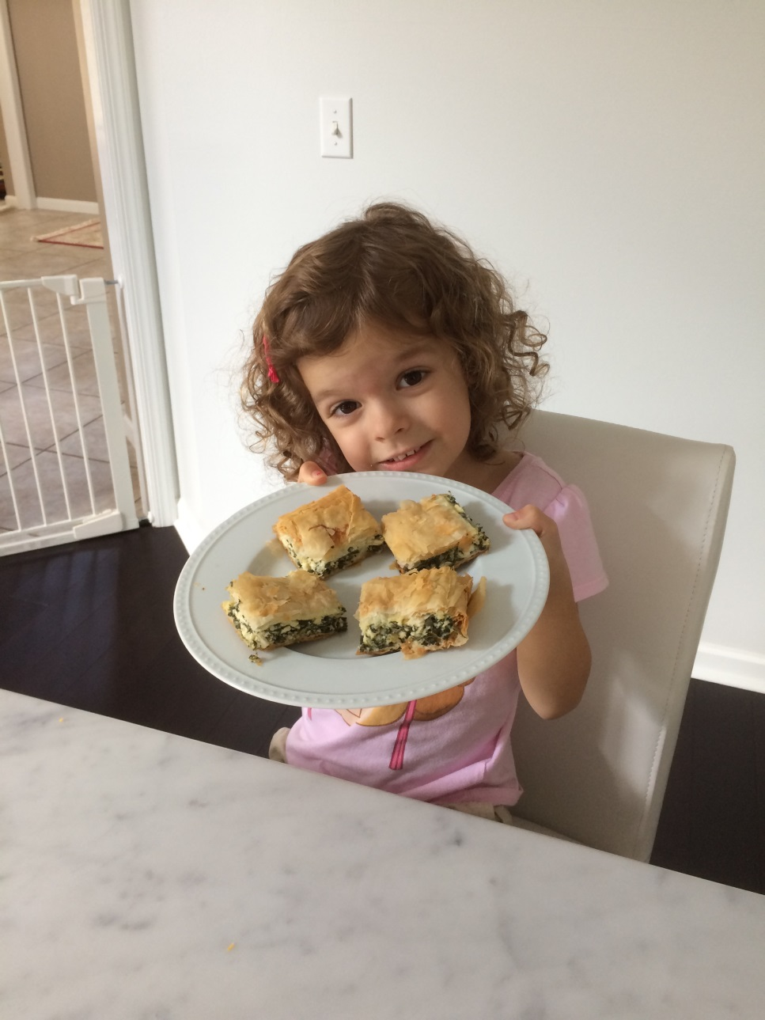

Ava puts the spanakopita in the oven for an hour and then cuts it into pieces for her family to eat! Delicious!

The End

