SULLIVAN BROTHERS

Tom Sullivan, age 59, dressed and got read for work. He was the only one awake in the cold, Kowa frame house that early in the morning.
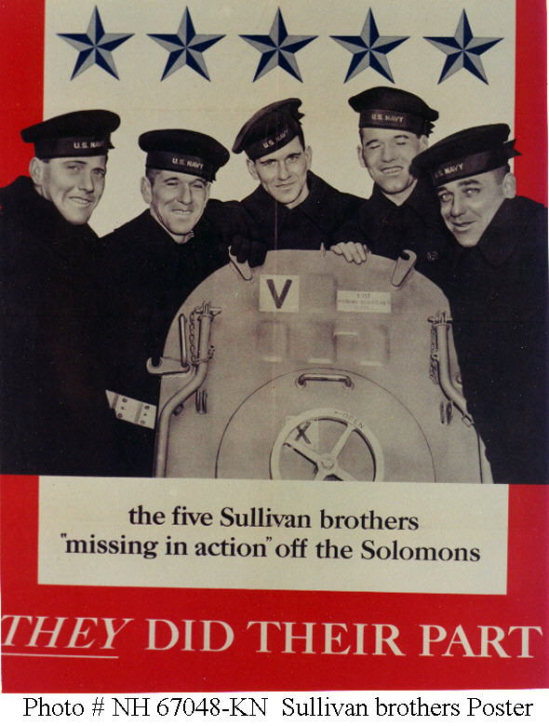
A railroad man, he was a vital part of the home front’s effort in World War 2, helping transport war material across the country. He was preparing breakfast when he noticed the black sedan arriving.
His heart sank immediately.
Eleven months prior, his 5 boys---Albert, Francis, George, Joseph, and Madison – had enlisted with the Navy less than a month after Perl Harbor. Their only stipulation: they insisted on serving together.
Putting 5 brothers on the same ship was against standard procedure for the the Navy, but they agree and allowed them to continue the family motto: “We stick together”.
On Valentine’s Day, 1942, the USS Juneau, a heavy cruiser, was commissioned and the Sullivan brothers went off to war. The boys wrote home to their mother every chance they got, all the way until November, when the letters suddenly stopped coming.
That was why Tom Sullivan’s heart sank when that black sedan pulled up. He knew what it was there for. Three men in naval uniforms, dressed in dark bridge coats with gold trim and buttons, came to the front door.
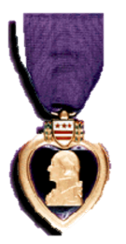
Lieutenant Commandeer Thomas Jones wallowed hard and said” I have some news about your boys.”
“Which one” Tom Sullivan responded.
“All Five,”
The boys had been in Combat off the shores of Guadalcanal in the Solomon Islands. A Japanese submarine snuck up on them, and one of their torpedoes scored a direct hit. The explosion was so massive it launched one of the 5 inch gun turrets over half a mile away. The Juneau sank in 20 seconds.
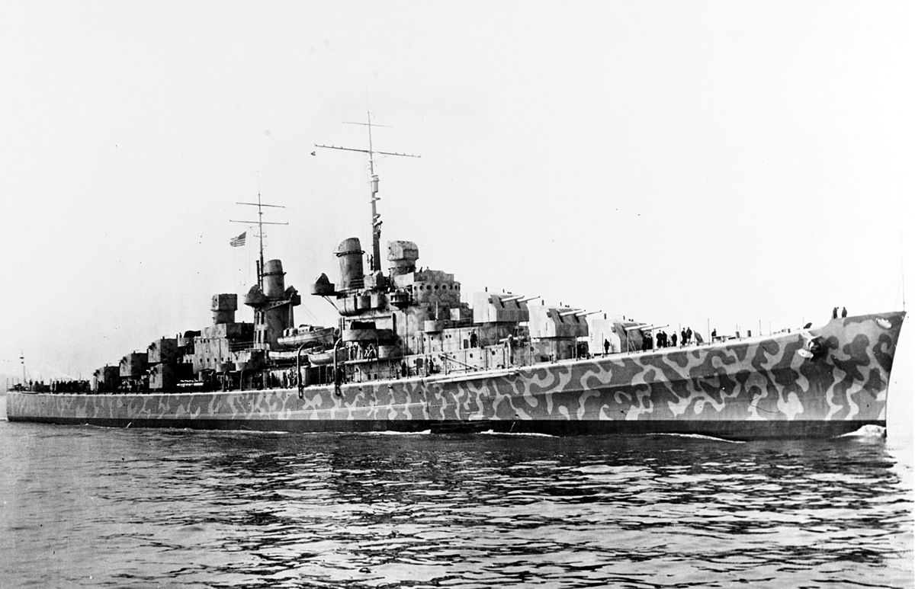
The other ships sailed away assuming no survivors, But about 100 of the 700 crewmembers of the Juneau slowly bobbed to the surface still alive.
One of them was George Sullivan, the eldest of the Sullivan brothers. Most of the men around him clung to nets and other debris floating in the several-inch thick coating of oil over the water.
But George, screaming his younger brothers’ names, found some toilet paper , and swam from person to person, wiping the oil off their faces, looking for his brothers.
He never found them.
Four days later, George Sullivan was killed by the sharks that had moved in. Many of the 10 survivors of the USS Juneau heard his cries of anguish for the rest of their lives. The Sullivan brothers’ mother Alleta always ended her letters to her boys with the advice “keep your chin up.” The surviving Sullivan’s tried to heed her advice. In fact, Tom Sullivan when to work the very day he received the telegram about his 5 sons—his wife insisted.
That’s how dire the war was. Those were the stakes at the time.
Mr. and Mrs. Sullivan went on to visit over 200 manufacturing plants and shipyards, offering encouragement to employees building the arsenal of democracy, in hopes of bringing the war to an end sooner. It is estimated they spoke to more than a million workers, and million more over the radio.
Tom Sullivan remarked: “What I felt is this, if we had more planes and more ships out their in the Solomon’s the cruiser Juneau wouldn’t have been sunk and our boys wouldn’t have been lost.”
America answered the Sullivan’s call.
One of the shipyards they visited was the Brooklyn Naval Yard in New York, where one of the greatest battleships ever built, the USS Iowa, was constructed.
Names after the Sullivan’s’ very own home state the USS Iowa was commissioned on President’s Day 1943, just a few months after the Sullivan brothers lost their lives.

SULLIVAN, MADISON ABEL
S2C US NAVY
WORLD WAR II
DATE OF BIRTH: 11/08/1919
DATE OF DEATH: 11/13/1942
BURIED AT: SECTION MC SITE 31-M
ARLINGTON NATIONAL CEMETERY
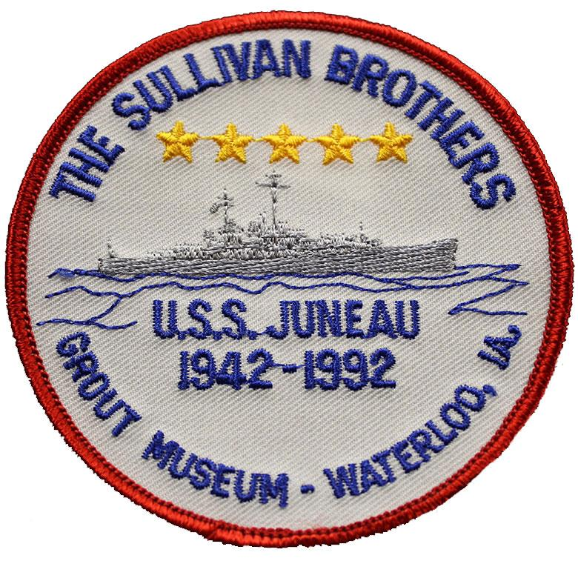
SULLIVAN, GEORGE THOMAS
GM2 US NAVY
WORLD WAR II
DATE OF BIRTH: 12/14/1914
DATE OF DEATH: 11/13/1942
BURIED AT: SECTION MC SITE 34-M
ARLINGTON NATIONAL CEMETERY
SULLIVAN, FRANCIS HENRY
COXN US NAVY
WORLD WAR II
DATE OF BIRTH: 02/08/1916
DATE OF DEATH: 11/13/1942
BURIED AT: SECTION MC SITE 33-M
ARLINGTON NATIONAL CEMETERY
SULLIVAN, JOSEPH EUGENE
S2C US NAVY
WORLD WAR II
DATE OF BIRTH: 08/28/1918
DATE OF DEATH: 11/13/1942
BURIED AT: SECTION MC SITE 32-M
ARLINGTON NATIONAL CEMETERY
SULLIVAN, ALBERT LEO
S2C US NAVY
WORLD WAR II
DATE OF BIRTH: 07/08/1922
DATE OF DEATH: 11/13/1942
BURIED AT: SECTION MC SITE 30-M
ARLINGTON NATIONAL CEMETERY

